IDE used in homework: Visual Studio Code

1. **Convert the image to a grayscale (monochrome) image using a library function.** 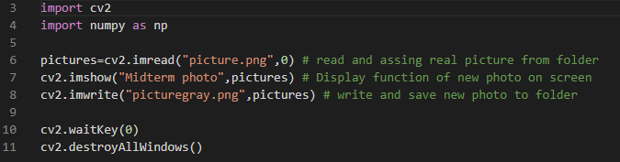

**Method in line 6: cv.imread(“picture.png”,0)** It saves the original photograph(RGB) that it reads from the folder as a single channel to the variable ,so it convert the image to grayscale (monochrome) image.

**Method in line 7: cv.imshow(“Midterm photo”,pictures)** This method displays the new version in the variable on the screen.

**Method in line 8: cv.imwrite(“picturegray.png”,pictures)** This method saves the new version shown on the screen to the folder with a new name.

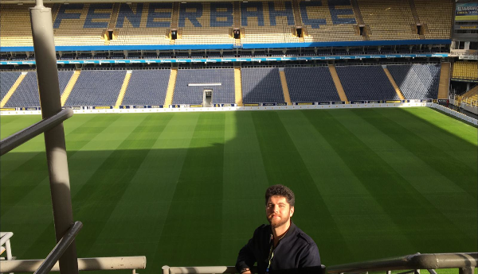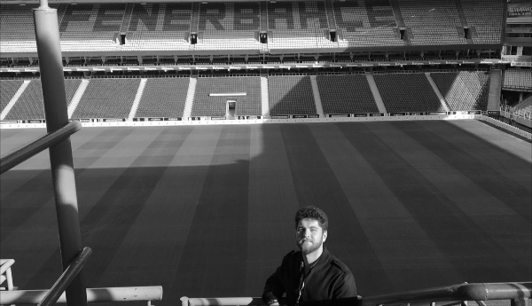

1. **By writing your own function called resizeToQuarter, which takes in a grayscale image as input, make the image smaller so that the number of pixels is decreased to 1/4.**

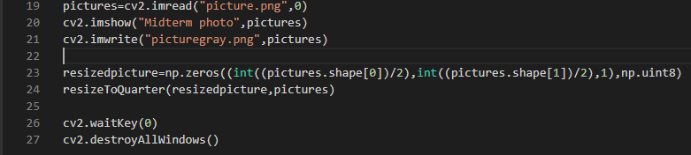

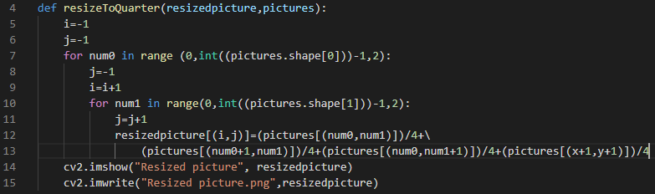

**ALGORİTHM**

First of all, the width and length of gray photo were calculated (with pictures.shape[0], pictures.shape[0]). Then a new empty photo named x with half of both dimensions was created with np.zeros((x,y,1),np.unit8) methods from numpy library. Next Step is to send the empty photo and the gray photo to the created method named resizeToQuarter. This function takes the average of every 4 pixels of the gray photo and turns it into a pixel of the empty photo.

|  |  |  |  |
| --- | --- | --- | --- |
|  |  |  |  |
|  |  |  |  |
|  |  |  |  |
|  |  |  |  |

|  |  |  |  |  |  |  |  |
| --- | --- | --- | --- | --- | --- | --- | --- |
|  |  |  |  |  |  |  |  |
|  |  |  |  |  |  |  |  |
|  |  |  |  |  |  |  |  |
|  |  |  |  |  |  |  |  |
|  |  |  |  |  |  |  |  |
|  |  |  |  |  |  |  |  |
|  |  |  |  |  |  |  |  |
|  |  |  |  |  |  |  |  |

4 Pixels average -1 Pixel

**RESULT**

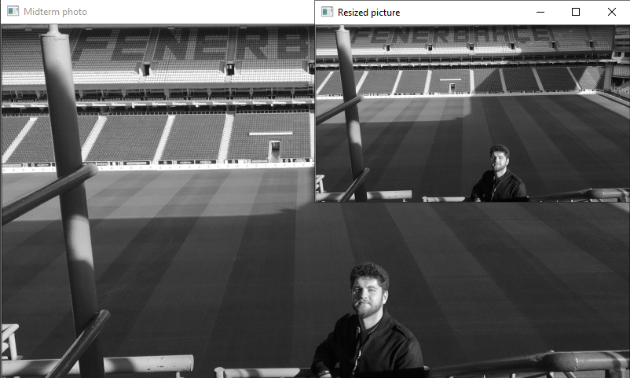

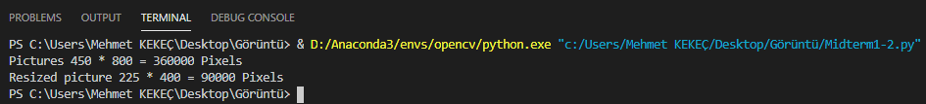

1. **Write a function/method called mySharpening, which applies the Laplacian filter given below to its input image.**

Given Filter:

|  |  |  |
| --- | --- | --- |
| **-1** | **-1** | **-1** |
| **-1** | **9** | **-1** |
| **-1** | **-1** | **-1** |



**ALGORITHM**

|  |  |  |  |  |  |  |  |  |  |  |  |  |  |  |  |  |  |  |  |
| --- | --- | --- | --- | --- | --- | --- | --- | --- | --- | --- | --- | --- | --- | --- | --- | --- | --- | --- | --- |
| **x** | **x** | **x** | **x** | **x** | **x** | **x** | **x** | **x** | **x** | **x** | **x** | **x** | **x** | **x** | **x** | **x** | **x** | **x** | **x** |
| **x** | **x** | **x** | **x** | **X** | **x** | **x** | **x** | **x** | **x** | **x** | **x** | **x** | **x** | **x** | **x** | **x** | **x** | **x** | **x** |
| **x** | **x** | **-1** | **-1** | **-1** | **x** | **x** | **-1** | **-1** | **-1** | **x** | **x** | **x** | **x** | **x** | **x** | **x** | **x** | **x** | **x** |
| **x** | **x** | **-1** | **9** | **-1** | **…** | **…** | **-1** | **9** | **-1** | **x** | **x** | **x** | **x** | **x** | **x** | **x** | **x** | **x** | **x** |
| **x** | **x** | **-1** | **-1** | **-1** | **x** | **x** | **-1** | **-1** | **-1** | **x** | **x** | **x** | **x** | **x** | **x** | **x** | **x** | **x** | **x** |
| **x** | **x** | **x** | **x** | **x** | **x** | **x** | **x** | **x** | **x** | **x** | **x** | **x** | **x** | **x** | **x** | **x** | **x** | **x** | **x** |
| **x** | **x** | **x** | **x** | **x** | **x** | **x** | **x** | **x** | **x** | **x** | **x** | **x** | **x** | **x** | **x** | **x** | **x** | **x** | **x** |
| **x** | **x** | **x** | **x** | **x** | **x** | **x** | **x** | **x** | **x** | **x** | **x** | **x** | **x** | **x** | **x** | **x** | **x** | **x** | **x** |
| **x** | **x** | **x** | **x** | **x** | **x** | **x** | **x** | **x** | **x** | **x** | **x** | **x** | **x** | **x** | **x** | **x** | **x** | **x** | **x** |
| **x** | **x** | **x** | **x** | **x** | **x** | **x** | **x** | **x** | **x** | **x** | **x** | **x** | **x** | **x** | **x** | **x** | **x** | **x** | **x** |

Note: Each x value is different from each other and is in the range of [0.255].

After applying the filter for each pixel, the filter is moved in the direction of the arrow.

**CODE:**

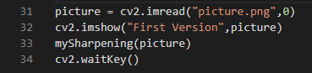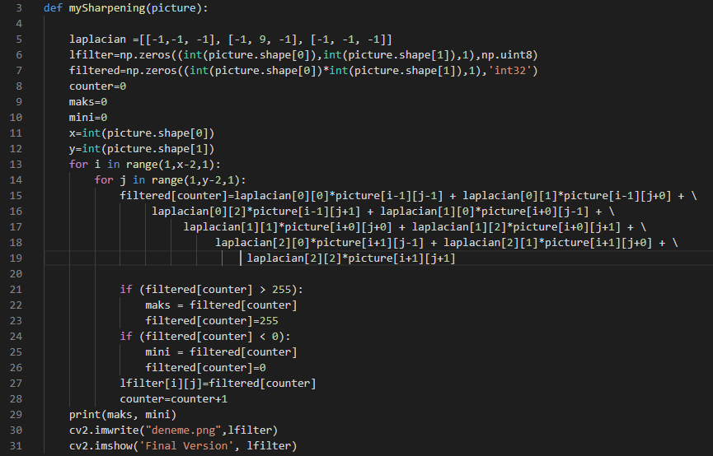

As can be seen from the code, after applying the filter, the values corresponding to each pixel are compressed into the range [0.255]. The reason for this is to prevent the excessive tips (-8 * 255 or 9 * 255) that may occur as a result of the process from distorting the sharpness in the photograph. For this reason, all shades smaller than 0 are synchronized to 0. All shades larger than 255 are equalized to 255. If we did not compress it to this range ([0.255]), the photos could have been more gray in order to avoid this, noise removal may have to be done in the image.

**RESULT**

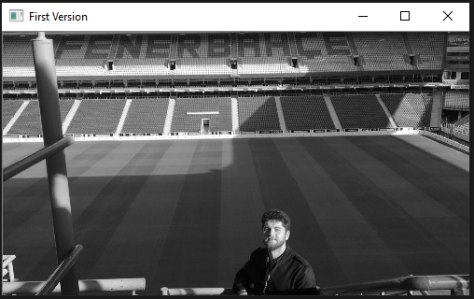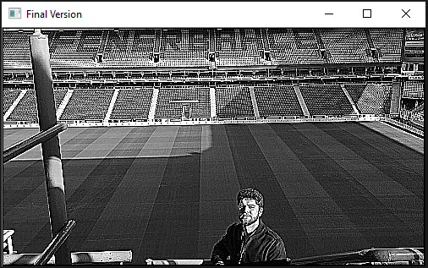



What would happen if the values were not compressed?

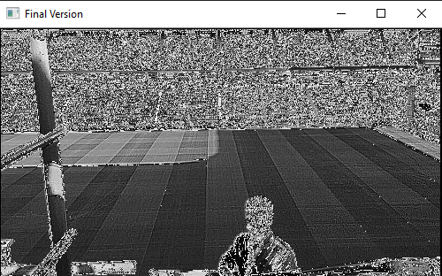



What would happen if laplacian was applied twice?

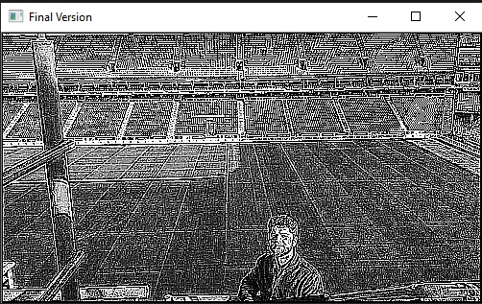

1. **You are given a noisy grayscale image together with this document. Perform noise removal to improve this image.**

First of all, the photo given was reduced by the ready-made re-size function.

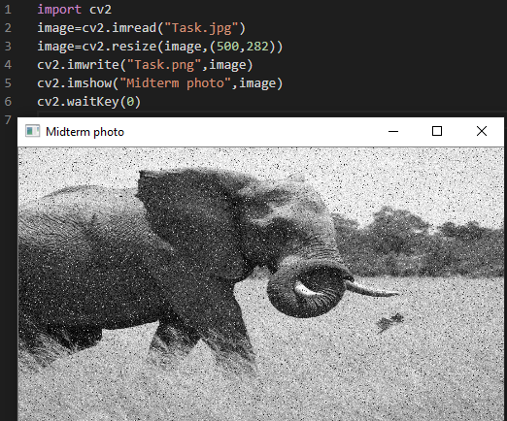

Secondly, The exam photo was processed with the median blur function. The function smoothes an image using the median filter with the ksize*ksize aperture. Each channel of a multi-channel image is processed independently.

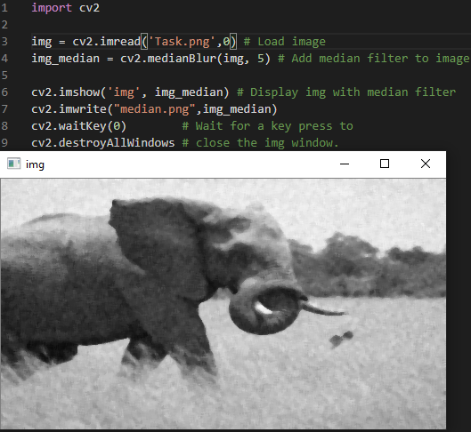

Thirdly, The fastNlMeansDenoising () method was used to further reduce the noise.

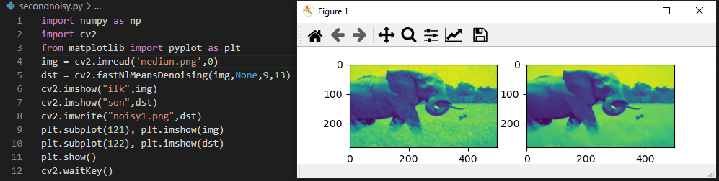

This method did not work very functional and effective for this picture.

To be seen more clearly;

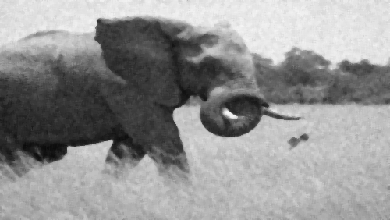

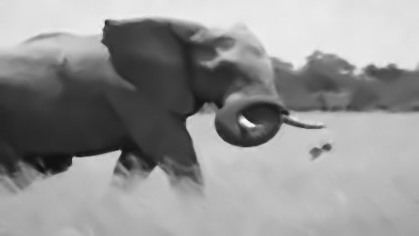

In the next step, the median method was reapplied and the photos were compared.

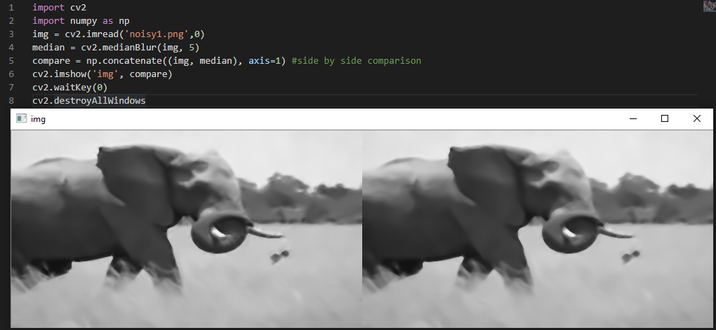

Again, it produced a successful result.

As a result,the most important conclusion after using these filters is still producing successful results even when the median blur function is used more than once. Another result is that the median blur function produces less successful results than the fastNlMeansDenoising method. At this point, the situation that should not be forgotten and should be noted is that; The parameter values of the fastNlMeansDenoising () method must be set very well. Otherwise, the desired results cannot be obtained, and in some cases the filter does not make any changes.

Some other filter results;

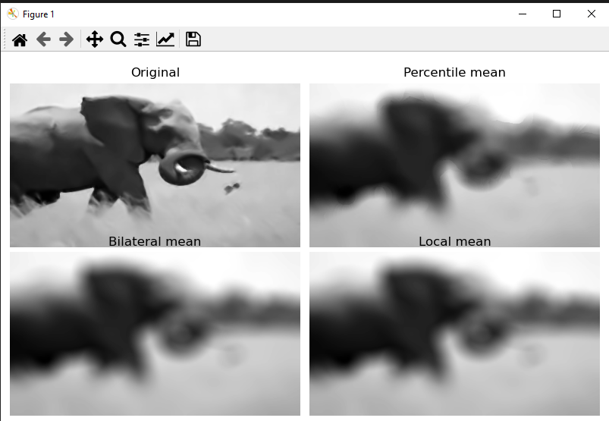

**APPENDICES- CODE**

**1-)**

import cv2

import numpy as np

pictures=cv2.imread("picture.png",0) # read and assing real picture from folder

cv2.imshow("Midterm photo",pictures) # Display function of new photo on screen

cv2.imwrite("picturegray.png",pictures) # write and save new photo to folder

cv2.waitKey(0)

cv2.destroyAllWindows()

**2-)**

import cv2

import numpy as np

def resizeToQuarter(resizedpicture,pictures):

    i=-1

    j=-1

    for num0 in range (0,int((pictures.shape[0]))-1,2):

        j=-1

        i=i+1

        for num1 in range(0,int((pictures.shape[1]))-1,2):

            j=j+1

            resizedpicture[(i,j)]=(pictures[(num0,num1)])/4+\

                (pictures[(num0+1,num1)])/4+(pictures[(num0,num1+1)])/4+(pictures[(num0+1,num1+1)])/4

    cv2.imshow("Resized picture", resizedpicture)

    cv2.imwrite("Resized picture.png",resizedpicture)

    print("Pictures",pictures.shape[0],"*",pictures.shape[1],"=",pictures.shape[0]*pictures.shape[1],'Pixels')

    print("Resized picture",resizedpicture.shape[0],'*',resizedpicture.shape[1],"=",resizedpicture.shape[0]*resizedpicture.shape[1],'Pixels')

pictures=cv2.imread("picture.png",0)

cv2.imshow("Midterm photo",pictures)

cv2.imwrite("picturegray.png",pictures)

resizedpicture=np.zeros((int((pictures.shape[0])/2),int((pictures.shape[1])/2),1),np.uint8)

resizeToQuarter(resizedpicture,pictures)

cv2.waitKey(0)

cv2.destroyAllWindows()

**3-)**

import cv2

import numpy as np

def mySharpening(picture):

    laplacian =[[-1,-1, -1], [-1, 9, -1], [-1, -1, -1]]

    lfilter=np.zeros((int(picture.shape[0]),int(picture.shape[1]),1),np.uint8)

    filtered=np.zeros((int(picture.shape[0])*int(picture.shape[1]),1),'int32')

    counter=0

    maks=0

    mini=0

    x=int(picture.shape[0])

    y=int(picture.shape[1])

    for i in range(1,x-2,1):

        for j in range(1,y-2,1):

            filtered[counter]=laplacian[0][0]*picture[i-1][j-1] + laplacian[0][1]*picture[i-1][j+0] + \

                 laplacian[0][2]*picture[i-1][j+1] + laplacian[1][0]*picture[i+0][j-1] + \

                      laplacian[1][1]*picture[i+0][j+0] + laplacian[1][2]*picture[i+0][j+1] + \

                           laplacian[2][0]*picture[i+1][j-1] + laplacian[2][1]*picture[i+1][j+0] + \

                                laplacian[2][2]*picture[i+1][j+1]

            if (filtered[counter] > 255):

                maks = filtered[counter]

                filtered[counter]=255

            if (filtered[counter] < 0):

                mini = filtered[counter]

                filtered[counter]=0

            lfilter[i][j]=filtered[counter]

            counter=counter+1

    print(maks, mini)

    cv2.imwrite("deneme.png",lfilter)

    cv2.imshow('Final Version', lfilter)

    return lfilter

picture = cv2.imread("picture.png",0)

cv2.imshow("First Version",picture)

img=cv2.imread("denem.png",0)

mySharpening(picture)

mySharpening(img)

cv2.waitKey()

**4-)**

**Resize Step**

import cv2

image=cv2.imread("Task.jpg")

image=cv2.resize(image,(500,282))

cv2.imwrite("Task.png",image)

cv2.imshow("Midterm photo",image)

cv2.waitKey(0)

**First Step Noising**

import cv2

img = cv2.imread('Task.png',0) # Load image

img_median = cv2.medianBlur(img, 5) # Add median filter to image

cv2.imshow('img', img_median) # Display img with median filter

cv2.imwrite("median.png",img_median)

cv2.waitKey(0)        # Wait for a key press to

cv2.destroyAllWindows # close the img window.

**Second Step Noising**

import numpy as np

import cv2

from matplotlib import pyplot as plt

img = cv2.imread('median.png',0)

dst = cv2.fastNlMeansDenoising(img,None,9,13)

cv2.imshow("ilk",img)

cv2.imshow("son",dst)

cv2.imwrite("noisy1.png",dst)

plt.subplot(121), plt.imshow(img)

plt.subplot(122), plt.imshow(dst)

plt.show()

cv2.waitKey()

**Third Step Noising**

import cv2

import numpy as np

img = cv2.imread('noisy1.png',0)

median = cv2.medianBlur(img, 5)

compare = np.concatenate((img, median), axis=1) #side by side comparison

cv2.imshow('img', compare)

cv2.waitKey(0)

cv2.destroyAllWindows